

***COMP3850 Project Deliverable Certificate***

| **Name of Deliverable** | *Deliverable 5* |
| --- | --- |
| **Date Submitted** | *30 / 10/ 2024* |
| **Project Group Number** | *14* |
| **Rubric stream being followed for this deliverable (highlight one)**  ***Note: the feasibility study has the same rubric for all streams.*** | *SOFTWARE Rubric*  *GAMES Rubric*  *CYBERSECURITY Rubric*  *DATA SCIENCE Rubric* |

We, the undersigned members of the above Project Group, collectively and individually certify that the above Project Deliverable, as submitted, **is entirely our own work**, other than where explicitly indicated in the deliverable documentation.

| **INITIALS** | **SURNAME** | **GIVEN NAME** | **STUDENT NUMBER** | **SIGNATURE  *(IN-PERSON OR DIGITAL)*** |
| --- | --- | --- | --- | --- |
| NM | Mahagoda | Ninuri | 46592156 | *NinuriM* |
| QN | Nguyen | Quoc Hung (Alan) | 47578130 | *AlanN* |
| AC | Chowdhury | Aasnayem Gazzali (Adam) | 46325824 | *Aasnayem* |
| NK | KHAN | Noorullah | 47197404 | *N Khan* |
| TV | Vilathgamuwa | Tashiya | 46992162 | *Tvilathg* |

*NB: please write all details clearly (if handwritten).*

*© Macquarie University, 2021*

**List of tasks completed for the deliverable and activities since last deliverable certificate with totals for each individual team member and whole team** *(copy individual total row for each member and copy pages if more pages needed)*

| **Performed by  *(Names)*** | **Duration *(hrs)*** | **Complexity  *(L, M, H)*** | **Name of task** | **Checked by  *(Initials)*** |
| --- | --- | --- | --- | --- |
| Noorullah Khan | 0.25 | Mid | Meeting: with Mingxin (17/10) | QN |
| Noorullah Khan | 0.5 | Mid | Meeting: Saturday Team Meeting (19/10) | NM |
| Noorullah Khan | 3 | High | Development: Experimenting Tailwind CSS (19/10) | AC |
| Noorullah Khan | 4 | High | Development: Re-Developing Website Layout with Tailwind CSS (19/10) | AC |
| Noorullah Khan | 2 | High | Development: Refining & Finalising Design (19/10) | AC |
| Noorullah Khan | 1 | High | Development: Fixing Flex Scaling Width issue (20/10) | AC |
| Noorullah Khan | 1 | Mid | Project: PM Tasks updated Jira (21/10) | QN |
| Noorullah Khan | 1 | Mid | Development: Light dev works, installed dependencies on Laptop (21/10) | AC |
| Noorullah Khan | 1 | High | Meeting: Pre-EY Meeting (21/10) | NM |
| Noorullah Khan | 1.5 | High | Meeting: With EY (22/10) | NM |
| Noorullah Khan | 2.5 | High | Meeting: After EY (22/10) | NM |
| Noorullah Khan | 1 | Mid | Project: Updating Jira tasks for sprint 7, adding AI team tasks (23/10) | QN |
| Noorullah Khan | 2 | High | Development: Creating new pages for website (23/10) | AC |
| Noorullah Khan | 1 | Mid | Project: Working on Presentation Deliverable 6 (24/10) | TV |
| Noorullah Khan | 1 | High | Development: Making the Home/Landing page (24/10) | TV |
| Noorullah Khan | 0.5 | High | Development: Editing the Login pages (24/10) | TV |
| Noorullah Khan | 1.5 | High | Meeting: With team to discuss AI Team's WebApp (24/10) | NM |
| Noorullah Khan | 2 | High | Development: Experimenting with API Key (24/10) | AC |
| Noorullah Khan | 1 | High | Meeting: With Caio, Josh, Akriti, Eugene about UI (25/10) | NM |
| Noorullah Khan | 2 | High | Development: API Integration into WebApp (25/10) | AC |
| Noorullah Khan | 1 | High | Development: API AI Prompt Engineering (25/10) | AC |
| Noorullah Khan | 1 | Mid | Development: WebApp testing & Demo (26/10) | AC |
| Noorullah Khan | 1 | High | Meeting: Saturday Team Meeting (26/10) | NM |
| Noorullah Khan | 0.5 | Mid | Project: PM Tool Jira updated (26/10) | QN |
| Noorullah Khan | 0.25 | Mid | Meeting: With Tash & Ninuri about slides (26/10) | TV |
| Noorullah Khan | 1 | Mid | Project: Working on Deliverables 5 and 6 (26/10) | TV |
| Noorullah Khan | 1 | High | Development: Azure chat playground (26/10) | AC |
| Noorullah Khan | 1 | High | Meeting: With Dan, Ngoc & Chenhao about prompts and training (26/10) | NM |
| Noorullah Khan | 1 | High | Development: Doing prompt engineering on azure (26/10) | AC |
| Noorullah Khan | 1 | High | Development: Prompt engineering Azure Deployment (26/10) | AC |
| Noorullah Khan | 2 | High | Development: Prompt Engineering in Front End API Calls (26/10) | AC |
| Noorullah Khan | 1 | High | Development: Re-designing main page of WebApp (27/10) | AC |
| Noorullah Khan | 2 | High | Development: Adding markdown cells and ask AI section (27/10) | AC |
| Noorullah Khan | 1 | High | Development: Adding History Page and making it work using API (27/10) | AC |
| Noorullah Khan | 0.5 | Mid | Meeting: With Alan & Adam (27/10) | QN |
| Noorullah Khan | 3 | High | Development: Adding Date fields and date functionalities (28/10) | AC |
| Noorullah Khan | 1 | Mid | Project: Re-writing deliverable 5 with updated webapp (28/10) | TV |
| Noorullah Khan | 1 | Mid | Project: Writing Presentation Script and practising Demo's (28/10) | TV |
| Noorullah Khan | 0.5 | Mid | Project: Going through other ppls Deliverable 5 and refining (28/10) | TV |
| Noorullah Khan | 0.5 | Mid | Development: Adding more claims and fields to claims.csv (28/10) | AC |
| Noorullah Khan | 0.25 | High | Development: Adding t a s, i a & i p to claim details (28/10) | AC |
| Noorullah Khan | 1.5 | High | Meeting: Pre-EY Meeting (28/10) | NM |
| Noorullah Khan | 1.5 | High | Meeting: With EY (29/10) | NM |
| Noorullah Khan | 3 | High | Meeting: After EY (29/10) | NM |
| Noorullah Khan | 0.5 | Mid | Project: Deliverable 6 slide & speech update (29/10) | TV |
| Noorullah Khan | 0.5 | Mid | Project: Sending Akriti Deliverable 6 resources (29/10) | QN |
| Noorullah Khan | 0.5 | Mid | Project: Re-writing deliverable 6 speech with Client Feedback (29/10) | TV |
| Noorullah Khan | 1 | High | Development: Updated askQuestion.js Prompt issue (29/10) | AC |
| Noorullah Khan | 2 | High | Development: Current Claims functionality (30/10) | AC |
| Noorullah Khan | 0.5 | Mid | Project: Asking marker about grading (30/10) | TV |
| Noorullah Khan | 0.5 | Mid | Project: showing marker the webapp and data pipeline (30/10) | TV |
| Noorullah Khan | 0.5 | Mid | Project: Updating Script for Deliverable 6 (30/10) | TV |
| Noorullah Khan | 0.5 | Mid | Project: Recording & observing non-technical person go thru app (30/10) | TV |
| Ninuri Mahagoda | 1 | Low | Deliverable 5: Look into Deliverable 5 create contents and assign tasks (18/10) | AC |
| Ninuri Mahagoda | 1 | Low | Deliverable 6: create content and assign parts (18/10) | AC |
| Ninuri Mahagoda | 1 | High | Meeting: Pre-EY Meeting (21/10) | QN |
| Ninuri Mahagoda | 1.5 | High | Meeting: With EY (22/10) | QN |
| Ninuri Mahagoda | 2.5 | High | Meeting: After EY (22/10) | QN |
| Ninuri Mahagoda | 2 | Mid | Deliverable 5: work on reflective report introduction (22/10) | AC |
| Ninuri Mahagoda | 4 | High | WebApp: create login and home page wireframe (22/10) | TV |
| Ninuri Mahagoda | 1.5 | High | Meeting: With team to discuss AI Team's WebApp (24/10) | QN |
| Ninuri Mahagoda | 2 | Mid | Deliverable 5: worked on reflective report: planning (24/10) | NK |
| Ninuri Mahagoda | 2 | Mid | Deliverable 5: worked on scope changes (24/10) | NK |
| Ninuri Mahagoda | 3 | High | WebApp: create wireframes for claim processing page with Tash (24/10) | TV |
| Ninuri Mahagoda | 1 | High | Meeting: Saturday Team Meeting (26/10) | QN |
| Ninuri Mahagoda | 0.25 | Mid | Meeting: With Tash & Ninuri about slides (26/10) | TV |
| Ninuri Mahagoda | 1 | mid | Deliverable 6: create speech (26/10) | AC |
| Ninuri Mahagoda | 1.5 | High | Meeting: Pre-EY Meeting (28/10) | QN |
| Ninuri Mahagoda | 5 | Mid | Deliverable 6: create slides with Tash (28/10) | NK |
| Ninuri Mahagoda | 1.5 | Mid | Deliverable 6: Practice speech for mock EY presentation | TV |
| Ninuri Mahagoda | 1.5 | High | Meeting: With EY (29/10) | QN |
| Ninuri Mahagoda | 3 | High | Meeting: After EY (29/10) | QN |
| Ninuri Mahagoda | 2 | Mid | Deliverable 6: edited slides based on mentor feedback with Tash (29/10) | TV |
| Ninuri Mahagoda | 3 | Mid | Deliverable 5: updated parts to add reflection | NK |
| Ninuri Mahagoda | 0.25 | Mid | Meeting: With Adam to discuss about sprint (29/10) | AC |
| Ninuri Mahagoda | 4 | Mid | Deliverable 5: editing and formating reflective report with Tash (30/10) | AC |
| Tashiya Vilathgamuwa | 1 |  | Deliverable 5: Start looking into sections required (19/10) | QN |
| Tashiya Vilathgamuwa | 1 |  | Deliverable 6: Looking into how to structure presentation (19/10) | QN |
| Tashiya Vilathgamuwa | 0.5 | Mid | Meeting: Saturday Team Meeting (19/10) | AC |
| Tashiya Vilathgamuwa | 1 | High | Meeting: Pre-EY Meeting (21/10) | AC |
| Tashiya Vilathgamuwa | 1.5 | High | Meeting: With EY (22/10) | AC |
| Tashiya Vilathgamuwa | 2.5 | High | Meeting: After EY (22/10) | AC |
| Tashiya Vilathgamuwa | 3 | High | WebApp: create wireframes for front-end with Ninuri (24/10) | NM |
| Tashiya Vilathgamuwa | 1.5 | High | Meeting: With team to discuss AI Team's WebApp (24/10) | NK |
| Tashiya Vilathgamuwa | 1 | High | Meeting: Saturday Team Meeting (26/10) | AC |
| Tashiya Vilathgamuwa | 4 | High | Deliverable 5: Complete my sections (26/10) | QN |
| Tashiya Vilathgamuwa | 2.5 | High | Deliverable 5: Completed second half of my sections for reflection report (27/10) | QN |
| Tashiya Vilathgamuwa | 2 | High | Deliverable 6: Wrote up a script for presentation (27/10) | NK |
| Tashiya Vilathgamuwa | 0.25 | Mid | Meeting: With Tash & Ninuri about slides (26/10) | NM |
| Tashiya Vilathgamuwa | 5 | High | Deliverable 6: Create slides with Ninuri (28/10) | NM |
| Tashiya Vilathgamuwa | 1.5 | High | Meeting: Pre-EY Meeting (28/10) | NK |
| Tashiya Vilathgamuwa | 1.5 | High | Meeting: With EY (29/10) | NK |
| Tashiya Vilathgamuwa | 3 | High | Meeting: After EY (29/10) | NK |
| Tashiya Vilathgamuwa | 2 | Mid | Deliverable 6: edited slides based on mentor feedback with Ninuri (29/10) | NM |
| Tashiya Vilathgamuwa | 1.5 | Mid | Deliverable 5: Completed a subsection in reflection report(29/10) | AC |
| Tashiya Vilathgamuwa | 4 | High | Deliverable 5: Editing and formatting reflection report with Ninuri (30/10) | NK |
| Quoc Hung (Alan) Nguyen | 1.5 | High | Meeting: With Adam to create SQL database | AC |
| Quoc Hung (Alan) Nguyen | 1 | High | Meeting: Pre-EY Meeting (21/10) | TV |
| Quoc Hung (Alan) Nguyen | 1.5 | High | Meeting: With EY (22/10) | TV |
| Quoc Hung (Alan) Nguyen | 1 | High | Meeting: Saturday Team Meeting (26/10) | TV |
| Quoc Hung (Alan) Nguyen | 1 | High | Development: set up connection to Azure for local development | NK |
| Quoc Hung (Alan) Nguyen | 2.5 | High | Development: migrated cleaning scripts to Azure Functions | NK |
| Quoc Hung (Alan) Nguyen | 3 | High | Development: migrated enriching scripts to Azure Functions | NK |
| Quoc Hung (Alan) Nguyen | 3 | High | Development: migrated synthesising scripts to Azure Functions | NK |
| Quoc Hung (Alan) Nguyen | 2.5 | High | Development: migrated merging scripts to Azure Functions | NK |
| Quoc Hung (Alan) Nguyen | 2 | High | Development: developed master script to run data pipeline | AC |
| Quoc Hung (Alan) Nguyen | 0.5 | Mid | Meeting: With Alan & Adam (27/10) | AC |
| Quoc Hung (Alan) Nguyen | 1.5 | High | Meeting: Pre-EY Meeting (28/10) | TV |
| Quoc Hung (Alan) Nguyen | 1.5 | High | Meeting: With EY (29/10) | TV |
| Quoc Hung (Alan) Nguyen | 2 | High | Development: Fixed scripts not being to be ran on Azure | AC |
| Quoc Hung (Alan) Nguyen | 0.5 | Mid | Meeting: With Adam to discuss separating scripts | NK |
| Quoc Hung (Alan) Nguyen | 1.5 | High | Uni: Prepared for presentation and practice | NM |
| Quoc Hung (Alan) Nguyen | 1 | Mid | Development: Added folder structure documentation to github | AC |
| Quoc Hung (Alan) Nguyen | 0.5 | Low | Development: Planning for README file to introduce github repository | NK |
| Aasnayem Gazzali Chowdhury(Adam) | 1.5 | High | Meeting: With Alan to create SQL database | AC |
| Aasnayem Gazzali Chowdhury(Adam) | 0.5 | Mid | Meeting: Saturday Team Meeting (19/10) | NK |
| Aasnayem Gazzali Chowdhury(Adam) | 1.5 | High | Research: On migrating SQL scripts to Azure | QN |
| Aasnayem Gazzali Chowdhury(Adam) | 2.5 | High | Development: Testing with Azure to migrate SQL database | NM |
| Aasnayem Gazzali Chowdhury(Adam) | 1 | High | Meeting: Pre-EY Meeting (21/10) | NK |
| Aasnayem Gazzali Chowdhury(Adam) | 1.5 | High | Meeting: With team to discuss AI Team's WebApp (24/10) | AN |
| Aasnayem Gazzali Chowdhury(Adam) | 1 | High | Meeting: Saturday Team Meeting (26/10) | AN |
| Aasnayem Gazzali Chowdhury(Adam) | 0.25 | Mid | Meeting: With Ninuri to discuss about sprint | NM |
| Aasnayem Gazzali Chowdhury(Adam) | 0.5 | Mid | Meeting: With Alan & Noor (27/10) | AN |
| Aasnayem Gazzali Chowdhury(Adam) | 1.5 | High | Meeting: Pre-EY Meeting (28/10) | NK |
| Aasnayem Gazzali Chowdhury(Adam) | 1.5 | High | Meeting: With EY (29/10) | NK |
| Aasnayem Gazzali Chowdhury(Adam) | 3 | High | Meeting: After EY (29/10) | NK |
| Aasnayem Gazzali Chowdhury(Adam) | 0.5 | Mid | Meeting: With Alan to discuss separating scripts | AN |
| Aasnayem Gazzali Chowdhury(Adam) | 1.5 | Mid | Research: On remapping and random sampling | NK |
| Aasnayem Gazzali Chowdhury(Adam) | 3 | Mid | Deliverable: Worked on deliverable 5 | NM |
| Aasnayem Gazzali Chowdhury(Adam) | 2 | Mid | Deliverable: Updated deliverable 5 | NM |
| Aasnayem Gazzali Chowdhury(Adam) | 2 | Mid | Project: Worked on the presentation slides | TV |
| Aasnayem Gazzali Chowdhury(Adam) | 2 | Mid | Project: Wrote the script for the presentation | NM |
| Aasnayem Gazzali Chowdhury(Adam) | 1.5 | Mid | Project: Practised the presentation | NM |
| Aasnayem Gazzali Chowdhury(Adam) | 0.5 | Mid | Deliverable: Further updating deliverable 5 | TV |
| Aasnayem Gazzali Chowdhury(Adam) | 1 | Mid | Project: Reviewed and modified the presentation | TV |
| **Ninuri Total** | 43.05 |  |  | Q |
| **Tahiya Total** | 38.25 |  |  |  |
| **Noorullah Total** | 63.75 |  |  |  |
| **Alan Total** | 28.0 |  |  |  |
| **Adam Total** | 30.25 |  |  |  |
| **TEAM TOTAL** | **203.75** |  |  |  |

# **Table of Contents**

**Table of Contents 11**

**1. Overview of the Fraud Detection Project 12**

1.1. Context and Purpose: 12

1.2. Team Roles and Responsibilities: 12

1.3. Project Scope and Objectives: 15

1.3.1. Scope 15

1.3.2. Exclusions (Out of Scope) 16

1.3.3. Constraints 16

**2. Initial Project Setup and Planning 17**

2.1. Initial Setup: 17

2.3.1. Project Management Tool (PM Tool) 17

2.3.2. Discord 18

2.3.3. GitHub 18

2.3.4. Azure 18

**3. Requirement Gathering 19**

3.1 Technology stack evaluation: 19

3.2 Options Analysis: 19

3.3 Communication and project management: 19

**4. Dataset Design and Development: 20**

4.1. High Level Solution Design (HLSD): 20

4.2. Data Collection: 20

4.3. Data Cleaning: 21

4.4. Data Enriching 21

4.5. Data Synthesisation 22

4.6. Data Merging 22

4.7. Reflection 22

**5. Front-End Design and Development: 23**

5.1. Initial Prototyping: 23

5.2. Interface Design: 24

5.3. Integration with AI Model: 25

5.4. Web App Testing: 26

**6. Key Learning Outcomes 27**

6.1. Technical Learnings: 27

6.2. Collaborative Experience: 27

6.3. Project Management: 28

**7. Final Reflections and Future Recommendations 28**

7.1. Overall Project Impact: 28

7.2. What Worked Well: 29

7.3. Areas for Improvement: 30

7.4. Next Steps and Future Development: 31

**8. Conclusion 31**

# **1. Overview of the Fraud Detection Project**

## **1.1. Context and Purpose:**

NRMA is one of the leading insurers in Australia and New Zealand and offers coverage for a range of assets including, cars, homes, travel, business, motorcycles, boats, caravans, and security. One main challenge that occurs when handling insurance claims is the prevalence of fraudulent claims that need to be examined and appropriately handled. Currently, to identify and handle fraud NRMA uses a lot of resources and time as they use manual detection methods to investigate suspected fraudulent claims. This results in lengthy waiting periods, inefficient use of resources, and an increased chance of errors when investigating claims. Ultimately, fraud continues to occur making a loss for NRMA as the offenders often change the methods of submitting fraudulent claims making it hard for agents to detect.

Thus, NRMA Insurance approached EY’s new AI and Data Team to simplify their claims process and uplift their current fraud detection capabilities. To do this NRMA looked for a solution using Generative Artificial Intelligence (GenAI) to improve their current fraud detection system. Therefore, we the Data Team (Team 14) while the AI Team (Team 13) are working together collaboratively to upgrade the fraud detection system. From the beginning it was clear that both teams would have to closely collaborate to ensure that the project aligned with the requirements - this was a key point that both teams underestimated initially however through early sprint feedbacks we recognised the importance of maintaining string communication.

* **Data Team:** the main objective of the data team is to create a high quality dataset of around 20,000 rows to accurately train the AI model created by the AI Team. With this as our objective we anticipated that we would have frequent changes in scope as we would have to alter the dataset to meet the requirements of both the client and AI team.
* **AI Team:** the main objective of the AI Team is to build an accurate GenAI model that provides responses to claims on how fraudulent they are. The model must be trained on high quality data and tuned to provide accurate responses in the form of a percentage and explanation.

The final objective is the creation of an end-to-end solution that has a user interface allowing for data to be ingested into a model. The GenAI solution must produce a result in the form of a percentage on how likely the claim is to be a fraud and provide information to the claims officer so they can determine whether the claim was fraudulent or not.

Working on this project has enabled us to work collaboratively with other disciplines, enhancing our technical and interpersonal skills, and allowed us to use our knowledge and experiences to solve real-world issues.

## **1.2. Team Roles and Responsibilities**:

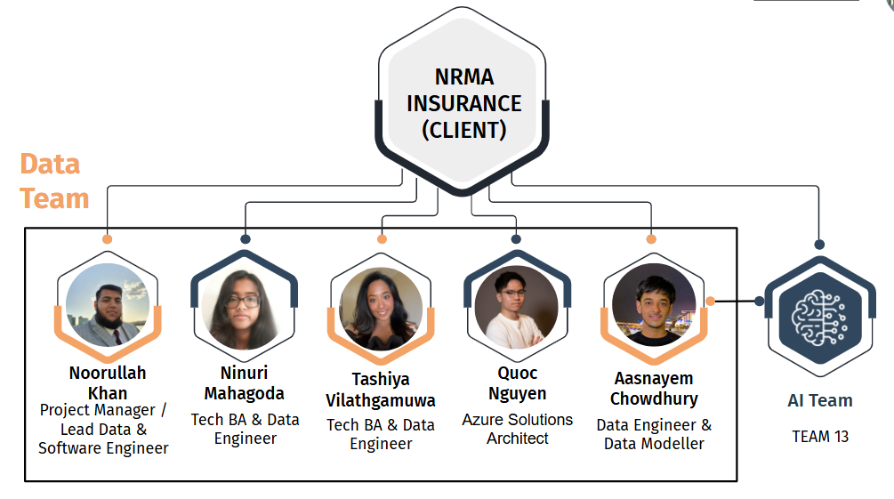

When we were first introduced to the project our team organisation was displayed to be structured like the above figure. The Data Team and the AI Team both work independently with their own Project Managers and together to create the new system. Additionally, each team communicates with the Client on the project and process to facilitate communication and satisfaction as we alter the project based on feedback and new requirements from the client

**1.2.1 Team Organisation and Structure**

As we have 5 members we decided to use a flat hierarchy for our team structure as it allowed us to simplify our communication and allowed for easier team management. During the early stages of the project to distribute responsibilities within our team members we decided based on our skills, ability and willingness to complete the task. As our project progressed each member role also evolved to suit the changing demands and more specialised tasks. At first we had tasks assigned to each team member but as time passed we realised the importance of being adaptable and open to new responsibilities. Naturally team members started leaning towards tasks that played to their strengths. This transition not only enhanced our productivity but also motivated team members to explore beyond their comfort zones and acquire new expertise. One key learning curve was balancing workload across team members as roles evolved and became more challenging. Open communication and proactivity were crucial factors in avoiding bottlenecks as issues were solved before they became a bigger problem.

**Noorullah Khan:**

* Since the beginning of the project Noorullah was decided on to the **Project Manager** due to his previous experience and knowledge on working with teams and the project. He was responsible for assigning tasks, setting deadlines and communicating with the AI team's PM to make sure both teams are on the same page.
* In Sprints 1-2 he worked as a **Data Collector** in which he researched and found various high quality dataset that can be used in building our final dataset to train the AI model.
* From Sprint 3 Noorullah became a **Data Engineer** where he worked on preparing and organising the data found for the dataset as well as building the data pipeline on Azure reflecting the shift to more technical work in the project.
* From Sprint 6 Noorullah expanded to the role of **Software Engineer** and **Web App Developer** where he designed and developed the back-end and front-end of the user interface for the fraud detection system. This came with challenges on integrating our dataset and AI model through APIs requiring extensive testing and communication.

Experiencing this project and the various shifts in roles highlighted the importance of flexibility and multitasking. By being involved in both management and technical tasks, it resulted in some struggles in balancing leadership activities and project tasks. One main takeaway was the importance of proper communication and team bonding for the smooth functioning of the team.

**Tashiya Vilathgamuwa and Ninuri Mahagoda:**

* The main roles for both Tashiya and Nine are **Business Analyst’s** related tasks where they work collaboratively to create user stories for the project and interact with the client to determine their requirements and translate them back into the project.
* Through the course of the project they will be working as **Document Control Coordinators**. In this role they will be overseeing the quality of the Deliverables and ensure they are written in accordance with the rubric given by the University.
* In Sprints 3-5 with the increasing amount of tasks needed for the development of the dataset they took on the role of **Data Engineers**. Tashiya’s main focus is working finding methods to synthesise data and impute missing data while Ninuri worked on data cleaning, data imputation, and the code convention.
* From Sprints 6 with the shift to developing the front-end they will take on the role of **Web App Designer** where they work on wireframes to ensure the front-end meets the requirements of the client.

Shifting from Business Analyst roles to more technical roles was a challenging task, as both members had to pick up technical skills on the go. However, by engaging with new technologies and responsibilities both members were able to have a bigger role in the creation of the dataset and be able to adjust to the shifting project needs. A key takeaway from this experience was to always be open to new ideas and take on new challenges to help the team and the client.

**Aasnayem Gazzali Chowdhury:**

* In Sprints 1-2 Aasnayem worked as a **Data Collector** in which he researched data quality standards and worked with Noorullah to gather various high quality raw dataset that can be used in building our dataset.
* From Sprints 3 Aasnayem transitioned to a **Data Engineer** where he worked on cleaning, enriching, synthesising and merging the raw data with Noorullah to create the final dataset as well as build the data pipeline on Azure.
* From Sprint 7 Aasnayem took on the role of **Software Engineer** where he will help Noorullah in developing the front-end user interface for the fraud detection system.

Aasnayem’s evolving roles throughout the project was a challenging situation to adapt to however, it highlighted the importance of being adaptable and open to new responsibilities. One main takeaway was the experience was adjusting his workstyle to collaborate more effectively with different team members to facilitate smooth completion and communication.

**Quoc Hung (Alan) Nguyen:**

* Similar to the rest of the team, Quoc worked as a **Data Engineer** to assist the others in writing scripts to process the raw data and in altering the dataset to meet requirements.
* From Sprint 2 Quoc acts as a **DevOps Engineer** where he is responsible for managing the GitHub repository. This entails managing pull requests, the developing branches and keeping the main codebase clean.
* From Sprint 4 Quoc took on the role of **Cloud Solutions Architect and Infrastructure Lead** and managed the infrastructure of the solution on Azure as code and wrote scripts to automate the process of testing and continuous deployment.

Taking on the responsibility of creating the GitHub and running the Azure started off as a difficult task due to a lack of knowledge and experience in these areas. However, after close collaboration with the mentors and team mates he was able to promptly resolve issues and create a sound architecture to guide our project. A key takeaway from this experience was the ability to tackle new responsibilities that will be used in real world situations.

The success of our project heavily relied on how our team coordinated with each other in the face of challenges that demanded quick and flexible responses. Upon looking back at the project and analysing it further it was evident that being able to adjust in various roles and team interactions was extremely important. Creating an atmosphere that encouraged learning and teamwork enabled us to handle obstacles better and produce a solution that satisfied our clients requirements.

## **1.3. Project Scope and Objectives**:

### **1.3.1. Scope**

The scope of the project was to successfully develop and deliver a comprehensive fraud detection solution by combining a high quality dataset and AI model into a front-end system. We initially focused on the creation of the high quality dataset and collaboration with the AI team and clients to ensure seamless integration and progress. Our initial scope consisted of; Data Acquisition, Data Preparation, and Dataset Delivery. This was because the main priority at the time was to create a high quality dataset to train the AI model to provide accurate results. As the project progressed our scope transitioned to include the creation of the front-end for the claims officer. This included; creating the Fraud Detection Model, Training and Testing the model, and the creation of a User Interface. Ultimately, we had to deploy the entire project onto Azure as NRMA has a partnership with Microsoft to enable seamless integration with current infrastructure and capabilities for scalability. One main challenge we faced throughout this project was the changing and evolving requirements of the client which would force us to adjust timelines and push back deadlines. However, through this experience we learnt that having early stakeholder alignment as well as effective communication is a crucial part of managing the scope.

### **1.3.2. Exclusions (Out of Scope)**

* **AI Model Development:** This will be handled by AI team
* **Post Deployment Support or Maintenance:** This is beyond the handover phase and would be the responsibility of NRMA
* **Data visualisation (PowerBI):** Not a requirement of the client due to budget restrictions

Defining these exclusions in the scope was important as it allowed us to focus on key areas of the project. One issue that occurred was in the initial planning stages of the project our objective was to use a PowerBI dashboard to show visualisation of our data to the client. However, by communicating with the client we realised that it was beyond our scope due to the budget restriction we were on. This led us to waste time on researching and learning necessary skills however, taught us the importance of getting feedback from the client regarding what was in and out of scope.

### **1.3.3. Constraints**

* **Timeline:** The project must be finalised within the designated 8 sprints, with deadlines established for each phase.
* **Budget:** Adherence to the project budget is required, covering all expenses related to tools, resources and any unexpected costs.
* **Resource Availability:** The Team must use the resources provided by the client such as Azure logins.

The main constraints we had in this project were timeline, budget and resource availability. By working on a fixed budget and timeline we were challenged to find cost-effective solutions such as open source dataset from Kaggle and the free-tier services at Azure. The main issue we had was with Resource Availability and budget as it took the client a long time to provide us with logins, further, coupled with technical issues and budget limitations we had to develop our project locally before moving it to Azure. This forced us to revise timelines as we pushed back migrating to Azure and prioritising other tasks to complete the project. In future projects we would try to have contingency plans in case of any constraints to ensure we are not wasting time and being redundant.

# **2. Initial Project Setup and Planning**

## **2.1. Initial Setup**:

### **2.3.1. Project Management Tool (PM Tool)**

When we were deciding on a PM Tool to manage projects, organise tasks and assign responsibilities we looked through various options such as Monday.com and Jira. As we looked into Monday.com we found out that while it had all the functionalities and tools, we needed to purchase a premium account to have all members on the platform such as the AI team and the client. Thus, we opted to use Jira as our project management platform. Firstly, Jira allowed us to have all projects on the site allowing for smooth communication and clearer understanding of roles and responsibilities in each sprint. It also offered other functionalities such as, Gantt Charts for easier visualisation of the project, project boards which allows for a clearer overview of tasks and status at each sprint, and further allows for adding dependencies, milestones and assigning task members to certain tasks. Our group mainly used Jira for keeping track of tasks and managing projects. Although it helped us stay on top of our progress and hold ourselves accountable we faced some challenges initially when it came to outlining user stories and organising tasks in order of priority. To make use of Jira we held workshops as a team to deepen our grasp of Agile practices and learn how to craft user stories that work well. This training didn't just boost our ability to track tasks efficiently but also strengthened communication, within the team as a whole.

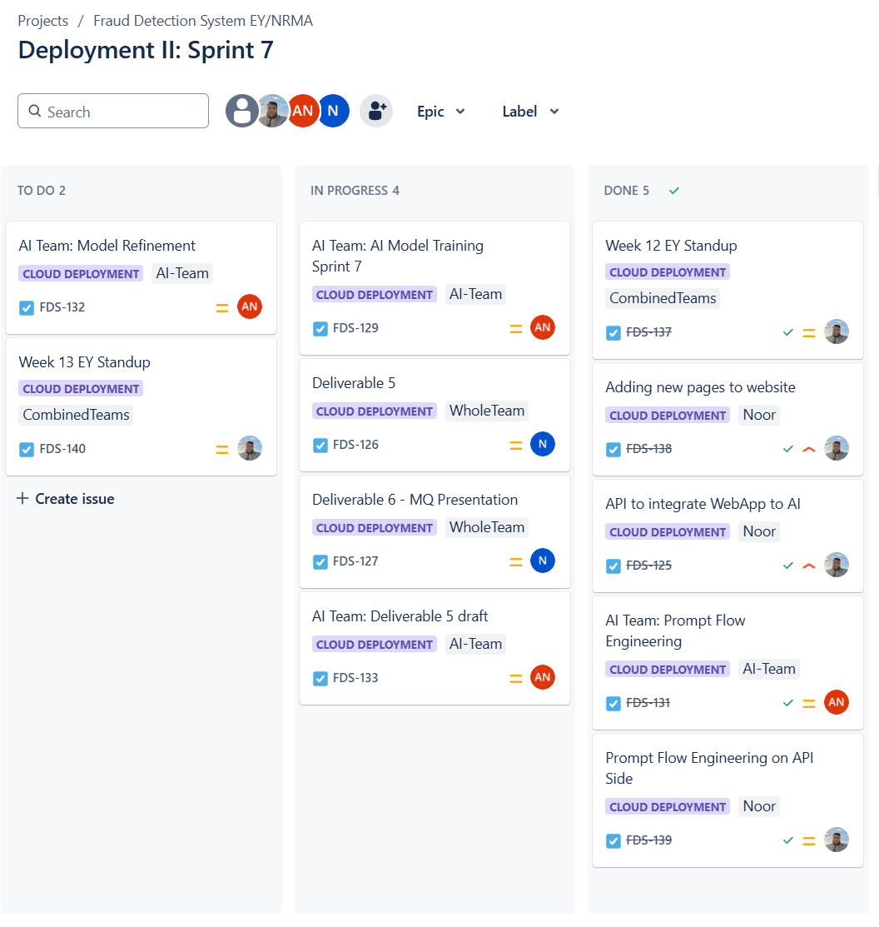

*Figure 1: Example Task Board*

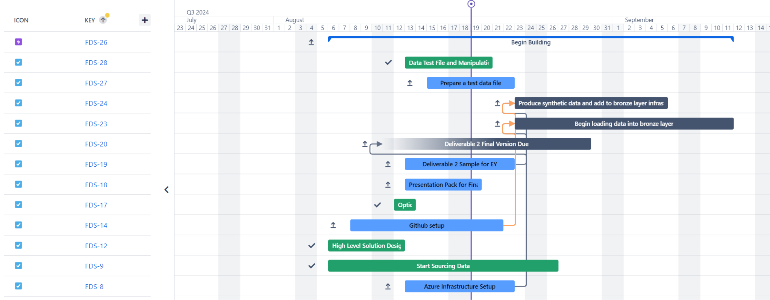

*Figure 2: Example Gantt Chart*

### **2.3.2. Discord**

To work on the project proper communication is needed between both the Data Team, AI Team, and the Client. Thus, to facilitate this we decided on discord due to its various features of separate organisable chat rooms and voice channel that allow smooth and clear communication. Some issues that arose in the early stages of the project is that the AI Team was not properly utilising the combined discord channel causing problems in early communication however, after some discussion we were able to have all members on the discord by Sprint 2.

### **2.3.3. GitHub**

To develop the project we decided to use GitHub as it allows all members to work collaboratively together on the same project and keep track of tasks that are being completed. GitHub Project is a tool that provides a Trello board to categorise tasks into various stages such as 'To Do,' 'In Progress,' and 'Completed. Furthermore, it allows us to create tickets for different issues, have branches to keep our main codebase stable while working on different tasks, and break down tasks to sub-tasks to make them more manageable. Due to the substantial difference of the project to any other experiences we had before there was some initial struggle creating and managing the GitHub. However, with guidance from the mentors we were able to get feedback and alter our GutHub to meet the requirements of this project. This allowed our team to see the importance of trying new tasks and not being afraid to ask questions.

### **2.3.4. Azure**

Azure was the main tool in which the project was to be deployed due to the business requirements of the client. While we did not get this tool til later on in the project it was still an important part of deploying our fraud detection system. One of the obstacles we faced revolved around Azure permissions. At first team members encountered challenges in accessing resources due to insufficient permissions, which impeded our ability to deploy models and conduct tests efficiently. We acknowledged the significance of resource access and thus put in place a process for requesting and granting permissions ensuring that all team members could access the necessary tools promptly without any unnecessary delays. Looking back on our interactions, these tools taught us the significance of setting up guidelines and keeping communication channels open at all times. By tackling these obstacles we not only improved our work processes but also strengthened the unity within our team.

# **3. Requirement Gathering**

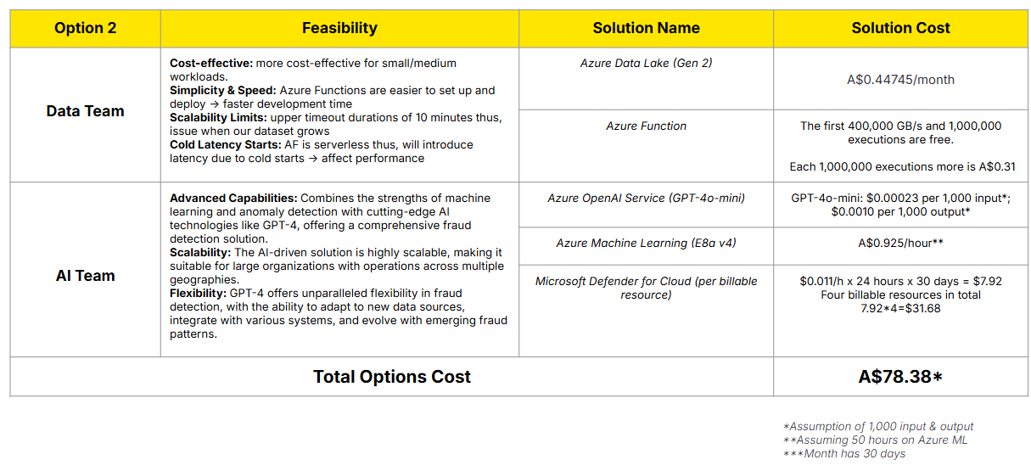

## **3.1 Technology stack evaluation:**

During our project with EY, we undertook a comprehensive evaluation of potential technology options, focusing on Azure data lake storage and Azure functions. Each option was assessed based on key criteria, including cost effectiveness, scalability, ease of integration and technical robustness. This structured evaluation ensured alignment with our project goals while considering the specific needs of our stakeholders.

## **3.2 Options Analysis:**

To facilitate our decision making process, we developed an options analysis framework that highlighted the advantages and limitations of each technology. Azure data lake storage stood out for its ability to scale efficiently accommodating the increasing data volumes throughout the project phases. This scalability combined with minimal storage costs made it a viable choice.

## **3.3 Communication and project management:**

Maintaining effective communication and project management was crucial throughout this process. We utilised project management tools to monitor progress and foster ongoing communication with key members. Regular updates and feedback sessions facilitated timely adjustments, ensuring our technology selections remained aligned with evolving project needs.

This structured approach to requirements gathering not only guided our decision making but also laid a strong foundation for successful project execution. By prioritising collaboration, evaluation and adaptability we positioned ourselves for effective outcomes in our engagement with EY.

# **4. Dataset Design and Development:**

## **4.1. High Level Solution Design (HLSD)**:

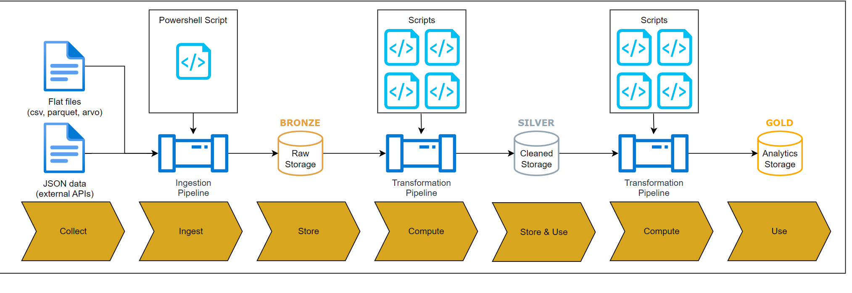

*Figure 3: HLSC Diagram*

During the kick-off of our project we were tasked in creating a HLSD of our process in creating a dataset to allow the client to see our thought process and how we aim to solve the issue:

* **Bronze layer:** is the first layer where we ingest and store our 3 raw datasets. This layer stores the raw datasets before any data cleaning takes place and this layer allows for reprocessing of our datasets if our cleaning and enriching methods are refined.
* **Silver layer: s**tores our datasets which are cleaned and enriched which is then ready to synthesise on. This layer is important because at this layer only data which is of a high quality is present making it a strong foundation for the AI model to be trained on.
* **Gold layer:** our final dataset where we have our three raw datasets and the two synthesised datasets combined. The gold layer is important as it stores our final dataset and this is used by the AI team to train their model which detects fraudulent claims.

## **4.2. Data Collection:**

From the start we realised that a key challenge would be to deliver a dataset of sufficient quality to the AI team to ensure that the model performed to standard. Gathering fraud specific data for automobile insurance claims in Australia with public sources was our initial roadblock due to the lack of reputable sources. However, after creating user stories and doing industry research we were able to identify our data requirements. This allowed us to filter through data sources easier as we knew what key features we were looking for. Such as, choosing datasets that have a “Fraud” column or a column which is similar as we are creating the dataset to train the AI model which will detect fraudulent claims.

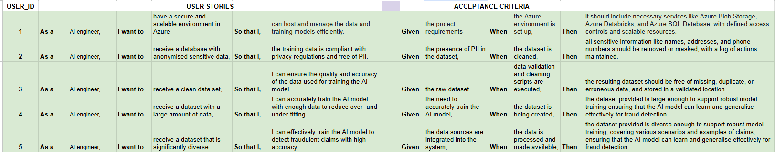

*Figure 4: User Stories*

We sourced our datasets from Kaggle as it is the most reliable source of datasets. We also looked at other sources for data such as Google Dataset Search but were unable to find a solid dataset to use. Firstly, we wanted to use a single dataset and synthesise it. Initially, we had one data source that fulfilled all our requirements as the basis of our dataset, however, after discussion with our clients and mentors, we decided to use 3 separate datasets. In the future, it would be better to do more research on alternatives and create an options analysis so we can have a better view of different methods as switching to 3 datasets increased our workload and pushed back our timeline.

## **4.3. Data Cleaning:**

Next, we started the process of checking the dataset by reviewing the accuracy and completeness of the data as well as its relevance to our work scope. Initially we used automated scripts to detect any information or discrepancies within the dataset. In our investigation we discovered deficiencies, in the 'CUSTOMER_EDUCATION_LEVEL' and 'OCCUPATION' sections where there were 665 and 500 instances of missing data correspondingly. Upon recognising the significance of these gaps in the data analysis process we decided to utilise the Random Forest imputation technique for classification values and KNN imputation for numerical values. This approach not only addressed the missing values but also preserved the original data relationships present in the dataset. We decided on these two primary methods through testing of various other imputation methods like Support Vector Regression alongside the percentage of accuracy for imputation values. As we showcased our process to the client they posed the question of why we did use the technique of AutoML which was easier however, with this comprehensive and detailed method we were able to get higher accuracy results and quality. This taught us that while there are easier methods to do tasks it is better to explore various different methods and make a more informed decision.

## **4.4. Data Enriching**

Next we had to enrich the dataset, to do this we either created new columns or dropped unwanted columns. After consulting with the AI team on what data their model needs to train we created new columns based on the weighted distribution of our primary dataset. While columns that were not necessary for the AI model were dropped. The decision to enrich the data before synthesis was a difficult choice as there were differing opinions between the mentors and the team. However, after some meetings we decided it was best to synthesise the important columns to get better and more relevant data for the dataset. This showcased the importance of having discussions and not letting fear hold you back from explaining your point of view.

## **4.5. Data Synthesisation**

Data synthesisation was a new experience for our team as we had no prior knowledge and experience on this. However, after some research we decided on using two different data synthesis methods (Remapping + Mathematical Sampling and CTGAN (Generative Adversarial Networks, a Neural Network based method. The main challenge for us was finding these two methods as identifying and testing these methods was a long process making us push back our other tasks to prioritise this. We were able to find our first method weekly but the second method took more than 2 weeks pushing back our deadline and affecting the AI teams model training. Another issue was the amount of data to synthesise from the data source, some mentors were accepting of synthesising more however, some pointed out the issue of bias with too many rows synthesised. Ultimately, we decided to synthesise 40% of the final dataset and were able to synthesise around 8,000 rows for our dataset.

## **4.6. Data Merging**

The final step is to merge our 3 cleaned and enriched data sources with our 2 synthesised datasets to create our final dataset of around 20,000 rows. Unique identifiers were also used which were the “index” columns across the datasets which ensured data integrity. The steps that we implemented made our dataset reliable which is then sent to the AI team to train their model on. This was created in an excel spreadsheet format and sent to the AI team for the training of their AI model. However, as they experimented with different model types we were tasked in creating datasets of different formats that suit their model. The first shift was from the excel format to the .json format for their model however, after that model didn’t have enough accuracy they requested a SQL database as the next format. These changes in requirements were unexpected tasks that would disrupt our flow and push other tasks behind creating some issues for our team. However, this highlighted the importance of proper communication between team members and other teams as we were able to overcome these challenges and provide them with complete and accurate datasets.

## **4.7. Reflection**

Since the beginning of our work on this project we understood that the quality and accuracy of our data had an impact on the reliability of our model and highlighted the importance of resolving any data quality issues before moving forward with model development. In looking back on this stage of the project we came to understand the significant value of having a thoroughly validated dataset. It not only served as the foundation for our modelling endeavours but also established a benchmark for data integrity that influenced all our future tasks. Through dedicating time to validation procedures we successfully developed a model that exhibited enhanced precision and trustworthiness ultimately resulting in more assured decision making processes.

# **5. Front-End Design and Development:**

## **5.1. Initial Prototyping**:

The initial concept for the fraud detection interface was developed using Figma, a collaborative design tool that enabled easy visualisation and efficient communication of design ideas among team members. Figma’s intuitive UI and real-time collaboration features allowed the team to sketch out ideas, define the user flow, and gather feedback from stakeholders before moving to code implementation.

In the prototyping stage, several key design decisions were made:

* **Simplicity & Efficiency:** The design focused on simplifying the workflow for claims agents by presenting essential information in a clear, organised layout. This minimised cognitive load and allowed agents to focus on important claim details, fraud indicators, and analysis results without distraction.
* **Color Scheme & Branding:** Inspired by NRMA’s branding, the interface uses NRMA’s official colours to ensure visual consistency and brand alignment. Soft, professional shades were chosen to create a reliable, trustworthy atmosphere.
* **Interactive Elements:** Figma enabled the team to prototype critical interactive components, such as buttons, dropdowns, and modal explanations, to mirror the user experience. This ensured smooth navigation and intuitive accessibility for claims agents.

The decision to use Next.js and Node.js as the main frameworks for the web app was based on:

* **Performance:** Next.js’s server-side rendering improves page load speed and user experience, while its built-in API routes facilitated smooth integration with backend services, including the fraud detection API.
* **Scalability:** Node.js offers a non-blocking, asynchronous runtime environment, supporting scalable backend solutions capable of handling multiple, simultaneous requests for real-time fraud analysis.
* **Developer Familiarity:** Both frameworks are widely adopted in the industry and are JavaScript-compatible, making them suitable choices for efficient development, maintenance, and future scalability.

To enhance the user experience further, the interface incorporates ReactMarkdown and remarkBreaks for structured and well-formatted fraud analysis summaries. Additionally, each claim entry captures essential dates, including the *incident date* and *application date*, ensuring agents have full historical context. For processed claims, an *outcome date* is recorded when a case is closed, approved, or escalated, allowing agents and auditors to track claim resolution timelines accurately.

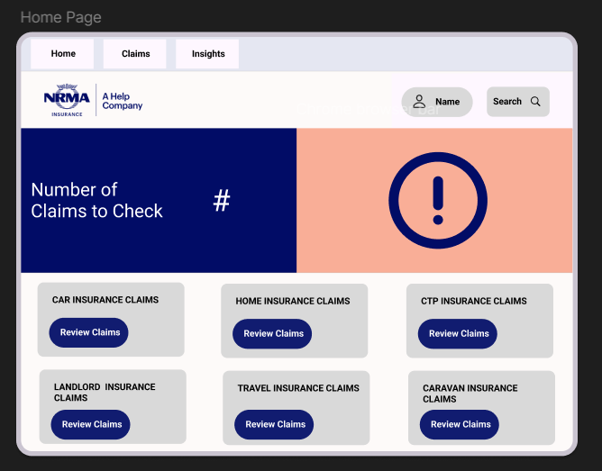 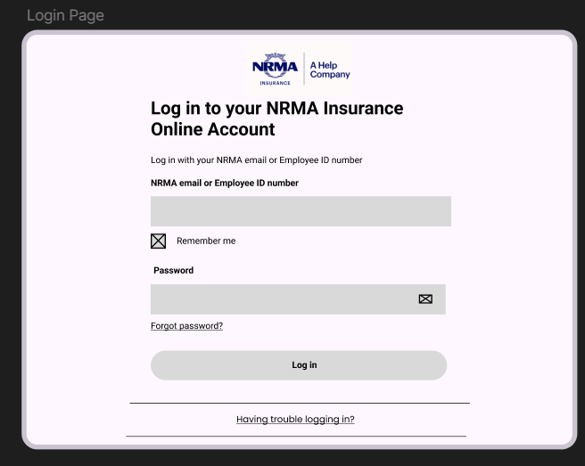

*Figure 5: Prototype of Home Page Figure 6: Prototype of Login Page*

## **5.2. Interface Design**:

The interface design was vital to ensure claims agents could assess claims efficiently and make informed decisions. The interface was built with several key features aimed at usability and functionality:

* **Login and Logout Functionality:** A secure login and logout feature protects sensitive data by restricting access to authorised users and managing session activity.
* **Dashboard & Claims Overview:** The main dashboard summarises pending claims, helping agents prioritise and manage cases efficiently. Key details like incident and application dates are displayed, with processed claims showing the outcome date for better tracking.
* **Real-Time Fraud Detection:** The fraud detection interface uses AI to assess fraud risk in real time, providing a fraud risk score and analysis summary for each claim. A colour gradient(green, orange, red) indicates risk level, guiding agents visually.
* **Explain More Function:** The “Explain More” button gives agents detailed insights into why a claim is flagged, using clear language to highlight potential fraud without needing deep AI knowledge.
* **Consistent Layout & Navigation:**Uniform design across pages includes a home button via the NRMA logo, quick logout through a profile icon, and a search bar for efficient information retrieval, ensuring streamlined navigation throughout.

These design choices were made to reduce agent fatigue, allowing for quick assessments and improving usability. By minimising the time required to analyse each claim, the interface enhances both productivity and the user experience for claims agents.

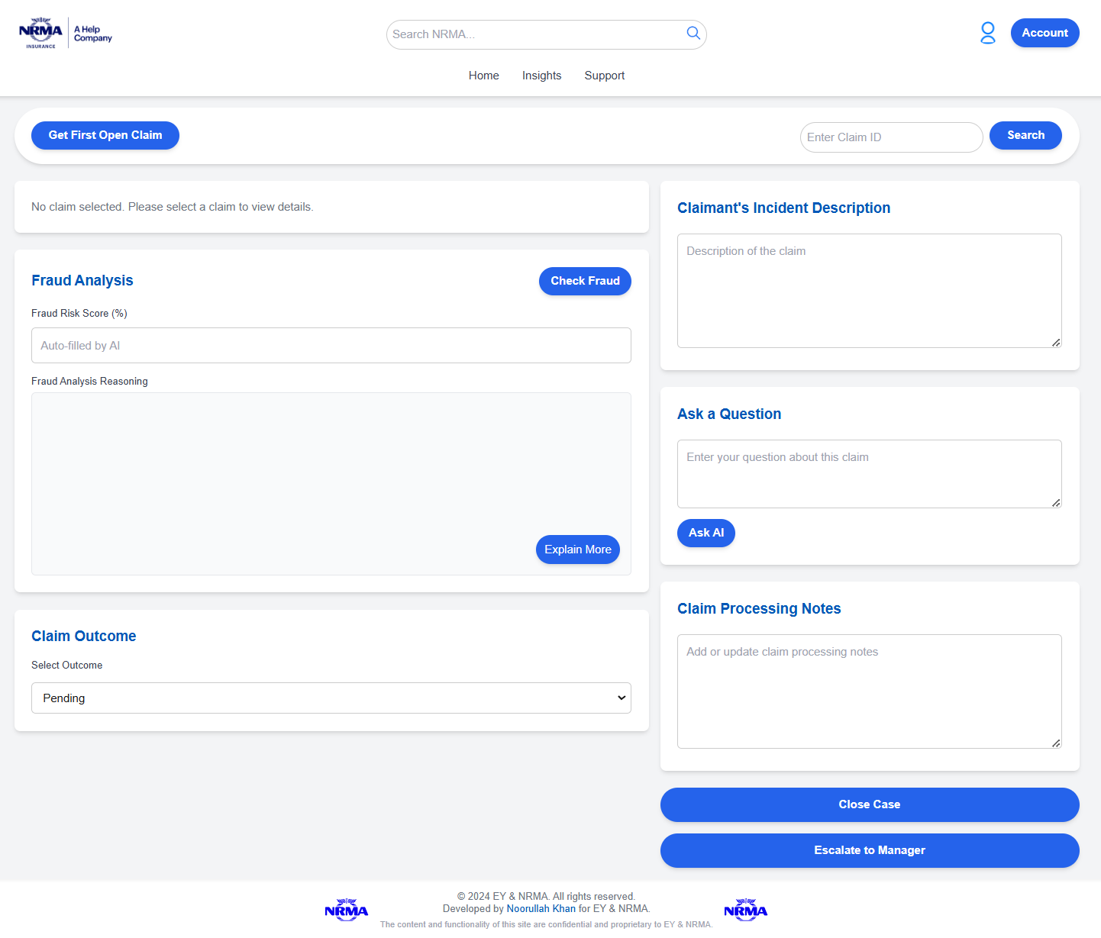

*Figure 7: Claim Processing Page*

## **5.3. Integration with AI Model**:

Integrating the AI model for real time fraud detection involved close collaboration with the AI team and several key steps:

* **API Development:** A backend API, built with Node.js, connects the web interface to the Azure OpenAI service hosting the AI model. This API processes claim details, generates a fraud risk score and returns an analysis summary on demand for each claim.
* **Prompt Engineering:** To streamline insights, the API uses prompt engineering, tailoring queries to highlight potential fraud indicators like claim amount, incident severity and customer tenure. This approach ensures relevant, consistent analyses without limiting broader AI capabilities.
* **Real-Time Fraud Detection and Colour Coding:** When “Check Fraud,” is selected, the API relays claim data to the AI , which returns a colour coded fraud risk score: Green for low risk, orange for moderate and red for high risk.
* **Ask AI Feature:** Agents can ask questions via the “Ask AI” feature, formatted for clarity with ReactMarkdown. This provides accessible, detailed responses from the AI on claim specifics or related topics.
* **Non-Functional Qualities & Error Handling:** Robust error handling and quick response times ensure a reliable experience, with clear feedback provided for connectivity issues.

By leveraging these elements, the fraud detection interface delivers a powerful, real-time AI solution that enables NRMA’s claims agents to make faster, data-informed decisions while maintaining a high standard of security and usability.

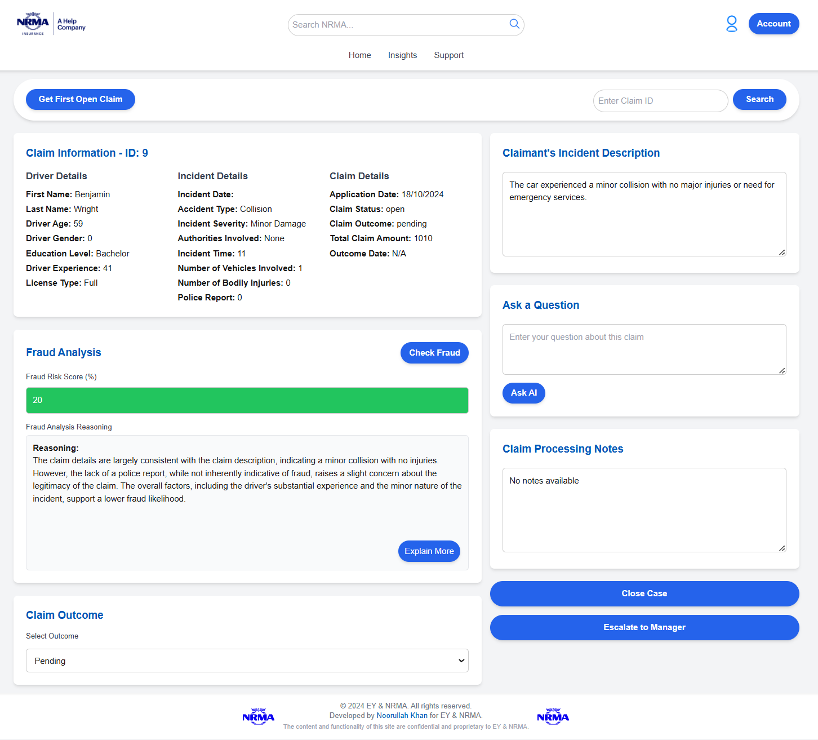

*Figure 8: Claim Processing Page with AI Response:*

## **5.4. Web App Testing**:

The web app testing process was primarily shaped by iterative feedback from our client, NRMA, who provided essential insights on aligning the application with their requirements. This client - centred approach gave us actionable guidance on refining the web interface to meet real world demands, even though our testing was limited to client feedback rather than broader user testing. Each update was informed by a cycle of client feedback, focusing on features, layout, and functionality to ensure the app’s usability and reliability. Reflecting on this process, we found that while client centred feedback loop kept us focused on their immediate priorities, additional end user testing might have further enriched our understanding of how the web app would perform in a real world setting.

**Key issues and updates based on client feedback:**

1. **User Interface and Navigation:** Based on the input from clients regarding navigation experience issues we revamped the dashboard to enhance accessibility significantly. This ongoing design process highlighted the impact of layout adjustments on user friendliness and emphasised the value of consistent early feedback on user interface design.
2. **Enhance performance of API:** In order to fulfil the clients requirement for data in detecting fraud instances effectively we enhanced the performance of the API to lessen delays in processing information. This input emphasised the connection between swift backend responses and user confidence and satisfaction which taught us that tackling operational effectiveness, from the outset can avert more significant problems later on.
3. **Error handling and notifications:** After considering feedback from clients perspectives and experiences with the system we enhanced error messages and notifications to enhance transparency and user friendliness.This valuable input emphasised the importance of error handling, in establishing user trust. A principle we aim to incorporate at the outset of upcoming projects.

While the client centred testing process for NRMAs requirements was pivotal in adapting to their needs, it also highlighted the drawbacks of depending solely on client input for feedback purposes alone. Introducing an user testing phase could have enhanced the approach by encompassing wider perspectives and enhancing overall usability. The lessons learnt emphasised the significance of harmonising responsiveness to client demands with a consideration of user experience to ensure that the end product aligns, with both specific and general user expectations.

# **6. Key Learning Outcomes**

## **6.1. Technical Learnings**:

From this project, we used many new tools such as Azure for a cloud solution, Javascript and Next.js for Web Development, Github for collaboration and Jira for project management.

At the start of the project, we did all of our work locally and pushed it on to our collaborative Github. By using github, we got used to collaboration within the team and this highlighted the importance of version control. Then, we moved onto Azure to migrate our local scripts and data to a cloud platform for scalability and security of the files. This experience enabled us to get used to a new platform of cloud computing which will deepen our knowledge while implementing a cloud solution. In terms of web development, we used javascript, next.js, node.js and ReactMarkdown and remarkBreaks primarily. All of these were unknown to us before starting the project. Through hard work and determination, we were able to make it work and come up with a functional web app which can give us a fraud risk score.

## 

## **6.2. Collaborative Experience**:

Collaborating closely with the AI team had an impact on how we approach our work and make decisions. It taught us important lessons in being adaptable and proactive in our communication efforts while emphasising the significance of maintaining clear documentation throughout the process. Our data preparation tasks were intricately linked with their model development needs due to this partnership, hence necessitating us to swiftly adjust to changing demands.

In essence, collaborating with the AI team has highlighted the significance of being adaptable, engaging in communication, and maintaining thorough documentation as essential elements for successful teamwork. This encounter has heightened our understanding of how adjusting our working methods and choices to synchronise with partner groups can significantly improve both the process and results in upcoming endeavours.

## **6.3. Project Management**:

* **Agile Practices and Conflict Resolution:** Implementing agile practices like sprints, epics, and stand-ups created a structured yet flexible environment. I also managed conflicts, both between and within teams, learning how to resolve issues constructively to keep everyone aligned on project goals.
* **Effective Time Management and Sprint Planning:** Working in two-week sprints within Atlassian’s project management tool Jira taught me how to balance short-term tasks with long-term strategic goals, structuring work into manageable sprints. I learned to create effective epics that broke down larger objectives into trackable milestones, which helped maintain momentum and direction.
* **Resource Allocation and Task Delegation:** Managing a diverse team of skillsets required understanding each team member’s strengths and assigning tasks that suited their expertise. I developed skills in delegating tasks across both our Data Team and the AI Team, ensuring efficient use of resources and setting a clear workflow in the PM tool.
* **Client Feedback Integration:** Weekly stand-ups with both teams and the client, along with frequent team meetings, provided consistent opportunities for feedback. I gained experience in incorporating client feedback efficiently while balancing it with project scope and technical feasibility.

# **7. Final Reflections and Future Recommendations**

## **7.1. Overall Project Impact**:

The projects conclusion brought about enhancements to NRMAs fraud detection system by improving its capacity to swiftly and accurately spot fraudulent claims with precision The development involved creating a specialised dataset through a meticulous process of acquiring data cleaning it synthesising it and validating it This laid the groundwork for training the AI model to pinpoint anomalies in claims The results are notably reflected in the reduced time spent on manual reviews by NRMAs claims agents and an expected drop, in operational expenses tied to fraud detection.

Collaborating extensively with the AI team ensured that the dataset met NRMAs business requirements and technical standards for the GenAI model implementation effectively.Apart from curating the dataset adequately;we designed a user interface, for claims agents to effortlessly engage with the AI model results.This intuitive interface provides agents with a tool to review and evaluate flagged claims enabling a seamless integration of the AI model into their everyday workflow. NRMA has received positive feedback about the AI models precision and the user friendliness of the interface which confirms the project's worth and its potential for continuous use, in NRMAs fraud detection system.

After fulfilling NRMAs needs as planned and agreed upon from the start of the project scope grew with the inclusion of a user facing aspect and transferring data procedures to Azure for enhanced scalability in upcoming phases.The newfound scalability grants room to adjust to changing demands in fraud detection—an advancement that solidifies this project as a valuable asset in both technical and strategic terms, within their business operations.

## **7.2. What Worked Well**:

Looking back at how the project unfolded and achieved success was due to a few factors that laid a strong groundwork, for the projects results;

**Agile Sprint Approach:** Using the approach enabled our team to work in small and iterative cycles that matched the clients evolving needs and the projects changing scope effectively. The iterative nature of Agile made it easier for us to receive feedback from the client and make necessary adjustments promptly based on NRMAs demands. For example When NRMA decided to remove data visualisation from the MVP scope The flexibility of sprints allowed us to shift smoothly by reallocating resources to enhance data accuracy and improve the claims processing interface. The flexible strategy reduced interruptions. Set the project up for success by making sure that the final outcomes matched closely with NRMAs goals.

**Enhancements in Dataset Quality and Accuracy:** Ensuring data quality was a focus of our project; our committed endeavours to enhance the accuracy and consistency of the dataset played a vital role in achieving exceptional performance of the AI model. Through the application of Exploratory Data Analysis (EDA) methods we were able to detect and rectify discrepancies as well as missing values and outliers throughout the dataset refinement stages, in the Bronze, Silver and Gold layers. By using techniques such as Random Forest and k nearest neighbours to fill in missing data and make sure all entries are consistent in our preparation process helped us create a dataset without much interference and with great suitability for training models effectively. The meticulous approach taken in managing the data significantly contributed to achieving model accuracy levels that were well appreciated, by both NRMA and the AI team.

**Collaborative Feedback Loops with the AI Team:** Collaborating closely with the AI team played a role in ensuring a successful project outcome with seamless efficiency and effectiveness in our workflow process.We found our weekly meetings to be highly beneficial for engaging in functional conversations that facilitated the adjustment of dataset structures and alignment of storage methods while promptly addressing infrastructure requirements as needed.One notable example is when we received feedback suggesting that JSON formatting would be more suitable, for the AI teams model design; we acted swiftly to modify our data pipeline accordingly by reorganising and verifying the data to align with the updated technical specifications. The knit teamwork approach made sure that both groups stayed on the same page and enabled us to promptly tackle problems and fine tune the data for the AI system while keeping the project schedule intact.

## **7.3. Areas for Improvement**:

**Earlier Communication with the AI Team on Technical Requirements:** AlthoughWe had some discussions with the AI team about technical needs in the past. We feel that having a clearer understanding of technical requirements, from the start would have made our project run smoother.On there was some confusion regarding data formats which led to switching from Excel to JSON and eventually settling on SQL. By setting up a defined procedure for aligning initial requirements. Maybe by organising an initial technical session. We could have predicted these changes, in format earlier on and reduced the efforts needed to reformat data while making sure that our resources were utilised more effectively.

**Proactive Planning for Tool Setup and Environment Preparation:** When we started setting up the development environments for Azure, Next.js and Node.js. We faced some delays because of unexpected complications in getting the new tools to work properly. Although we managed to overcome these delays it made us realise the significance of better preparation when deploying tools. For projects it would be helpful to have a specific setup period before diving into development, where the team gets familiar with the required tools and sorts out any compatibility problems, in advance. An exhaustive list of requirements to consider ahead of time before diving into installations at the stages and providing detailed guides could help simplify this procedure by cutting down the time taken for new team members to get up to speed and avoid delays when critical development stages kick in.

**Enhanced Cross-Training to Build Flexibility:** Team members had roles based on their expertise but having additional training in essential tools like dataset transformation and front end development could have given the team more flexibility. For instance teaching team members from roles of basic Next.js or data cleaning techniques could have allowed for a wider range of task assignments, in times of heavy workloads or tool related difficulties. Starting a project with a planned cross training program can enhance the team's ability to adapt to challenges effectively and work together seamlessly on projects that involve complex technical dependencies and require extensive collaboration.

## **7.4. Next Steps and Future Development**:

Expanding on the groundwork of this initiative are the suggestions aimed at enhancing the systems functionalities and guaranteeing its flexibility to meet NRMAs changing fraud detection requirements.

**Improving User Experience for Better Usability:** Expanding the interface to include more features would be a big help for NRMAs claims agents. They could benefit from having a feature that lets them organise claims by things like claim amount or type and likelihood of fraud. Moreover, putting in a dashboard to see fraud detection data in time could offer valuable insights into flagged claims trends making it easier for agents to make informed choices. If the budget permits it and there are no limitations in place consider looking into updating the way data is visually presented for past claims and detecting patterns of fraud as well. This could be beneficial, in helping agents quickly evaluate claims that have been flagged for review.

**Enhancing the Functionality of AI Models with Advanced Approaches:** To enhance and boost the precision of AI models in the future could entail improving the model with machine learning methods, like ensemble techniques or reinforcement learning strategies.This approach can improve fraud detection by merging models to generate a thorough analysis and adjusting to intricate and evolving fraud trends overtime. Regularly updating the model with claims data and fine tuning its parameters would help maintain the accuracy of the AI system and keep it in line with current fraud trends to protect NRMAs system from potential risks.

In summary the project has effectively provided NRMA with an flexible fraud detection system that brings quick operational improvements and sets the stage for future development. Through assessing the results strengths and areas, for enhancement of the project we have acquired insights to steer the next stages of NRMAs AI implementation process guaranteeing continuous harmony with their goals and operational requirements. Here are some suggestions that aim to help NRMA fully reap the advantages of this system by enhancing efficiency and reliability in their fraud detection procedures.

# **8. Conclusion**

This project was a key learning experience showcasing the importance of innovation, collaboration, and adaptability. We were able to combine both technical and business experience to create a solution to that improves NRMA’s current fraud detection system with GenAI. The project required us to go beyond our theoretical knowledge and were able to strengthen skills in data engineering, project management and agile development.

This opportunity has been a valuable experience for our future careers by offering personal and professional growth through improving our problem solving, collaboration and communication in a professional environment. This project highlighted the business impact of technology and the importance of staying customer focused while delivering solutions that provide value to the client. These past 5 months will significantly influence how we tackle intricate challenges in the future, equipping us to spearhead impactful initiatives that integrate technology with overarching business objectives.